3EJ4 Lab5

Name: Rui Qiu

Student Id: 400318681

*Part1:*

(1):

(2):

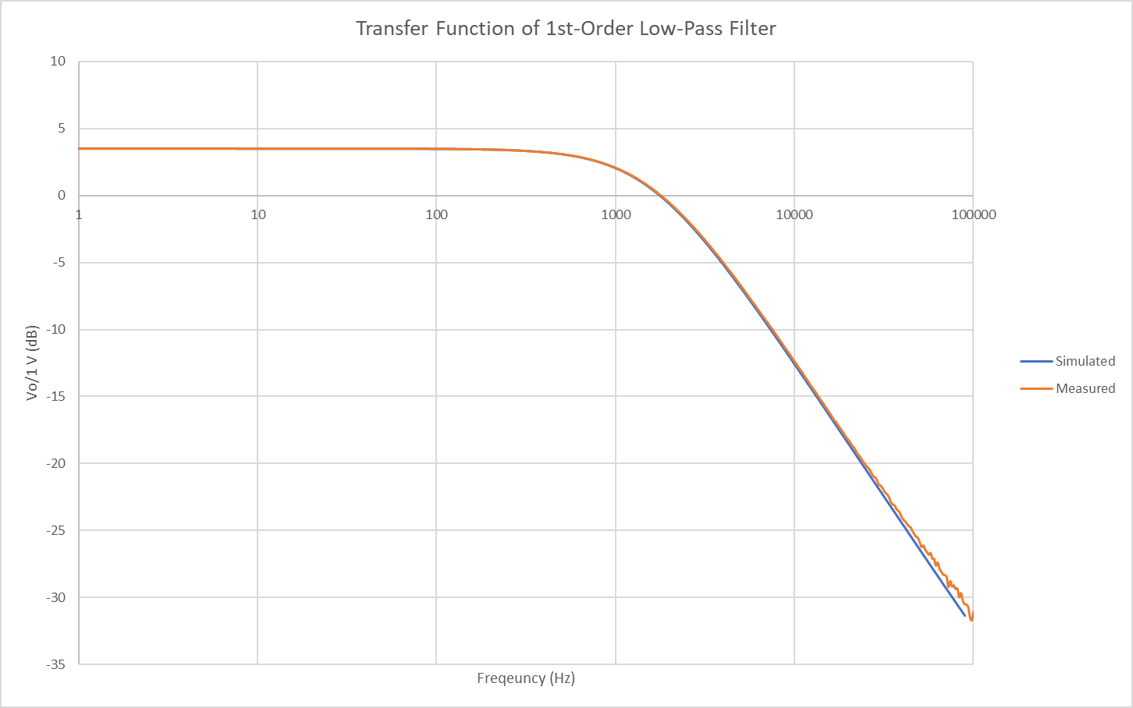

Both the simulated and the experimental transfer function graphs are very close to each other though they have different Vin input ac signal amplitudes, the simulation one has 1V and the experimental one has 100mV. The input ratio is 10:1 which is exactly the same ratio of the output Vout amplitude. Though the input value will change the output values, but based on the graph and the formula derived from (1), the gain of the active low pass filter will always be Vout/Vin which in this case, stays constant if there no components being switched.

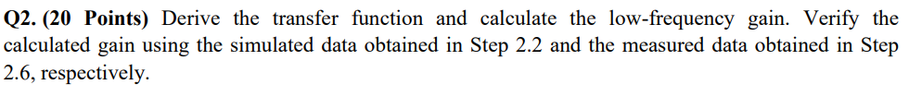

(1) By factoring the transfer function, we can get s = -3952 and s = -11503. Converting their absolute values to frequency by divide 2pi we can get fo = 629HZ and fo=1831HZ. The cutoff frequency can be calculated by dividing wo with 2pi and get fc=1073Hz. The fmax will be at the start of the transfer function 1Hz due to there are no zeros and the peak value is also the magnitude of the low-frequency gain.

|  |  |  |  |
| --- | --- | --- | --- |
|  | Calculated | Measured | Simulated |
| pole frequency fc (Hz) | 629 | 600 | 600 |
| cut-off frequency fc (Hz) | 1073 | 1095 | 1140 |
| pole Quality factor Q | 0.436 | N/A | N/A |
| peak value(dB) | 6 | 6.01 | 6.02 |
| frequency fmax (Hz) | 1 | 1 | 1 |



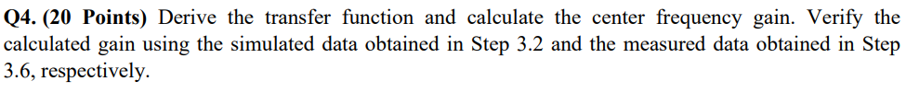



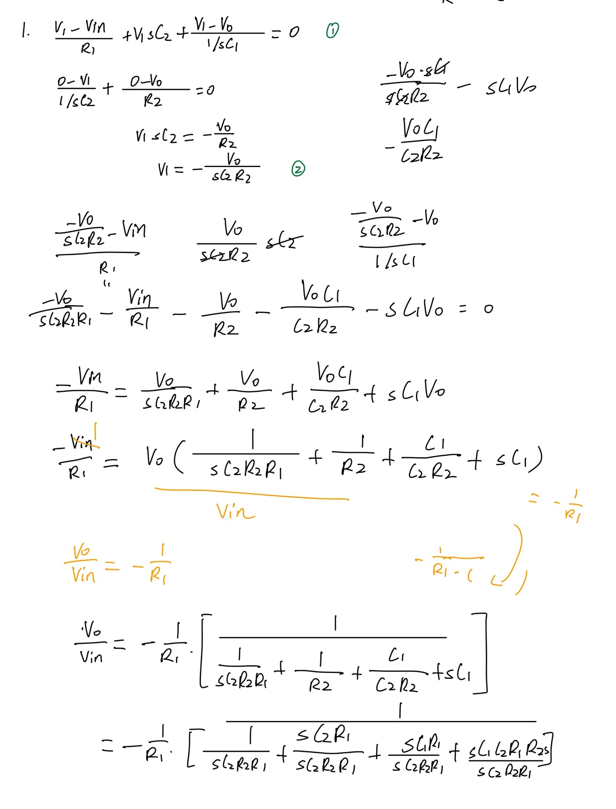

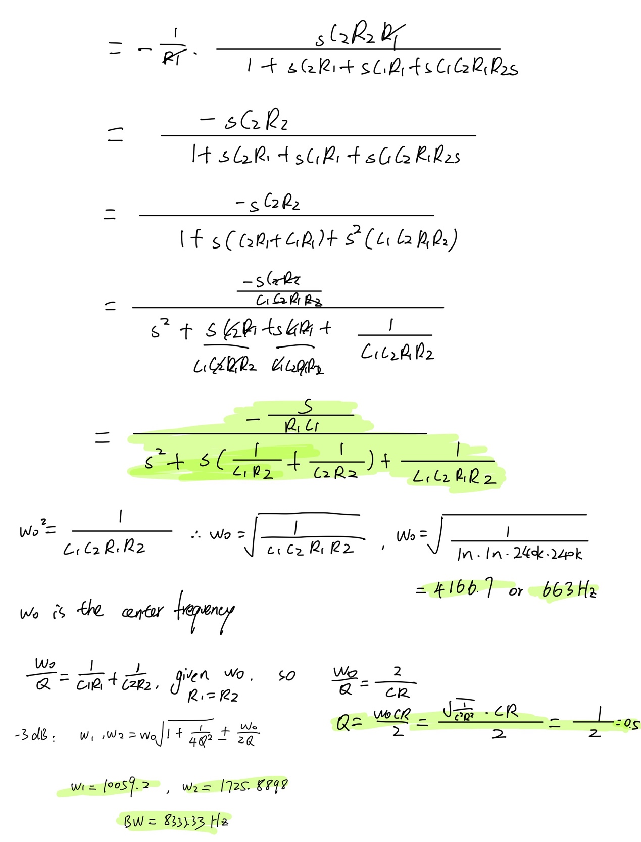

Based on the derivation shown above, the center frequency gain can be calculated as 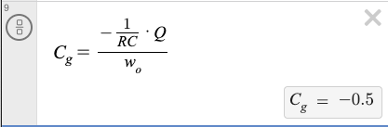 which is equal to -0.5 or -6.02dB. And the center frequency is 663Hz as calculated above.

By observing the center frequency, we can observe that both the simulation data have really close center frequency values as the calculated center frequency 663Hz and also the gain -6.02dB which verify the calculation.

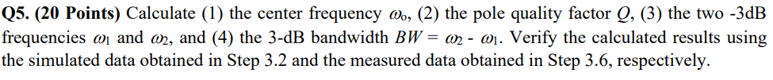

1. The center frequency wo is equal to 663Hz as calculated above.
2. The pole quality factor Q is 0.5 as calculated above.
3. The two -3dB, w1 = 1725.9 and w2 = 10059.2 in radians. And w1=274.7Hz, w2=1601Hz
4. The 3-dB BW= 8333.3 in radians. BW=1326.3Hz.

The center frequency is verified from the last question.

which is equal to -9.03dB.

And we can verify the gain from the graph as shown above. And their BW is close to the calculated value.

Simulation result:



BW = 1342

Measured result:





BW = 1349